Sept 18th, 2005
Web Site Revisions

A major overhaul of the SMG system was completed over the weekend. This overhaul encompasses many, many significant developments.

This memo covers many of the major upgrades and features that you will see online as well as some of the behind the scene changes that were made.

A new data center has been created in an undisclosed mountain location. The new data center has dual Internet lines to increase available bandwidth and provide for fail over service should one connection drop. A robust power back system was installed as well as a new web server and a development server and back up server, email functions were removed from the server that was hosting database functions to increase performance for both email and web services.
While these changes will make a big difference from a system standpoint, the changes that you will see and notice are immediately noticeable when you log in. The entire site has been redesigned and many new features have been added.

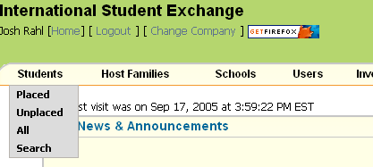The menu items have stayed the same, you shouldn’t have to worry about not knowing how to get to information, things still link up the same and you will see in many places, the same structure and layout that was originally there. The menu now runs across the top of the screen vs down the side on the old system. Depending on your level of access different options will show up if you place your mouse of the menu item. The menu names them selves are also links, i.e clicking on Students will also get you the list of students. You don’t have to select placed, unplaced, etc.

The entire website is also encrypted with 256-bit Secure Sockets Layer encryption. Once you have signed into the system, there are three ways you will be able to tell that the connection is secured. One is the https:// instead of the http:// in the url. There will also be a lock on the lower bar of your browser; it will look something like the image at left. There is also a Secure Site seal in the upper right corner whenever you are accessing a secure portion of the site. You can click on this image to see the security credentials.

The News & Announcements area is still present. A count of your placements is now displayed above this area, showing how many placements you have left to earn the

incentive trip. The Updates and Alert notifications will now display at the top of the page rather then down the side. They will still be in green and red boxes to get your attention.

For Area Reps Version:

The Current Items box still contains your progress report matrix. The processing side of the reports has been revamped to track reports better and the dual status on some reports will no longer show up. This should alleviate some confusion in submitting reports.

Under the New Users, instead of a count of the users, you will now see a list of the new users that have been assigned to you with links to there email and profile. (Regional Advisors and Regional Directors Only)

For Office Users version:
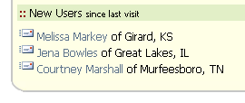The Current Items section has had some changes made to it. Under the New Users section, instead of just a count, it shows the new users added and a link to there profile and email.
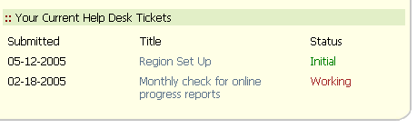

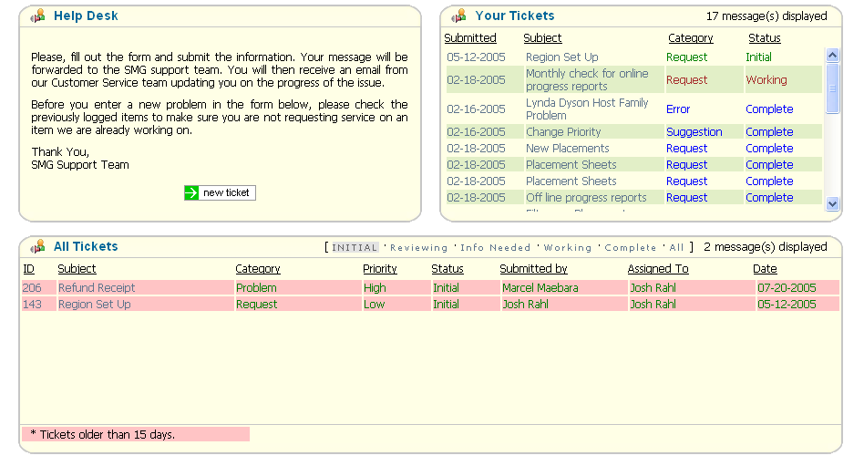 There is also a section for the Help Desk. It shows your current items that you have submitted to and there status. Clicking on the ticket title will take you to the full ticket in the help desk so you can add comments, reply, etc. The Help Desk section has been revamped organizing items that have been submitted to you along with a view of other items submitted as well.

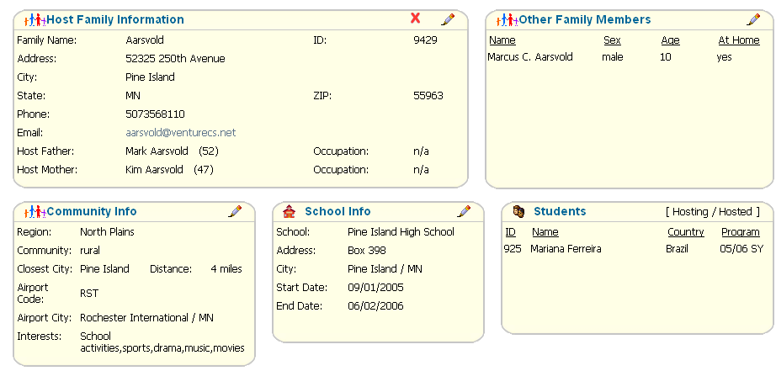A family over has been created so that you can see all the information on a host family on one screen, rather then switching between different screens. If you want to edit some information, simply click on the icon.

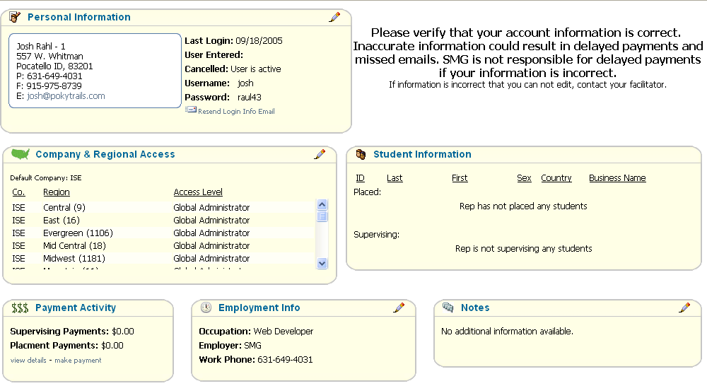Your account information has also changed a bit and now includes tracking for you payments. You can view this info my going to Users -> My Information

These are the major changes that will be immediately noticeable. There are many other new features in the system that you will discover as you use it. We will also highlight new features, as usual, in the Updates Section and the News & Announcements.

Thanks for you patience over the weekend as this change has taken place. Please
take a few minutes to play around with the new system, as you will be amazed at the changes and the ease of operation that they create.
As always, your comments & suggestions are always appreciated.

Regards,

